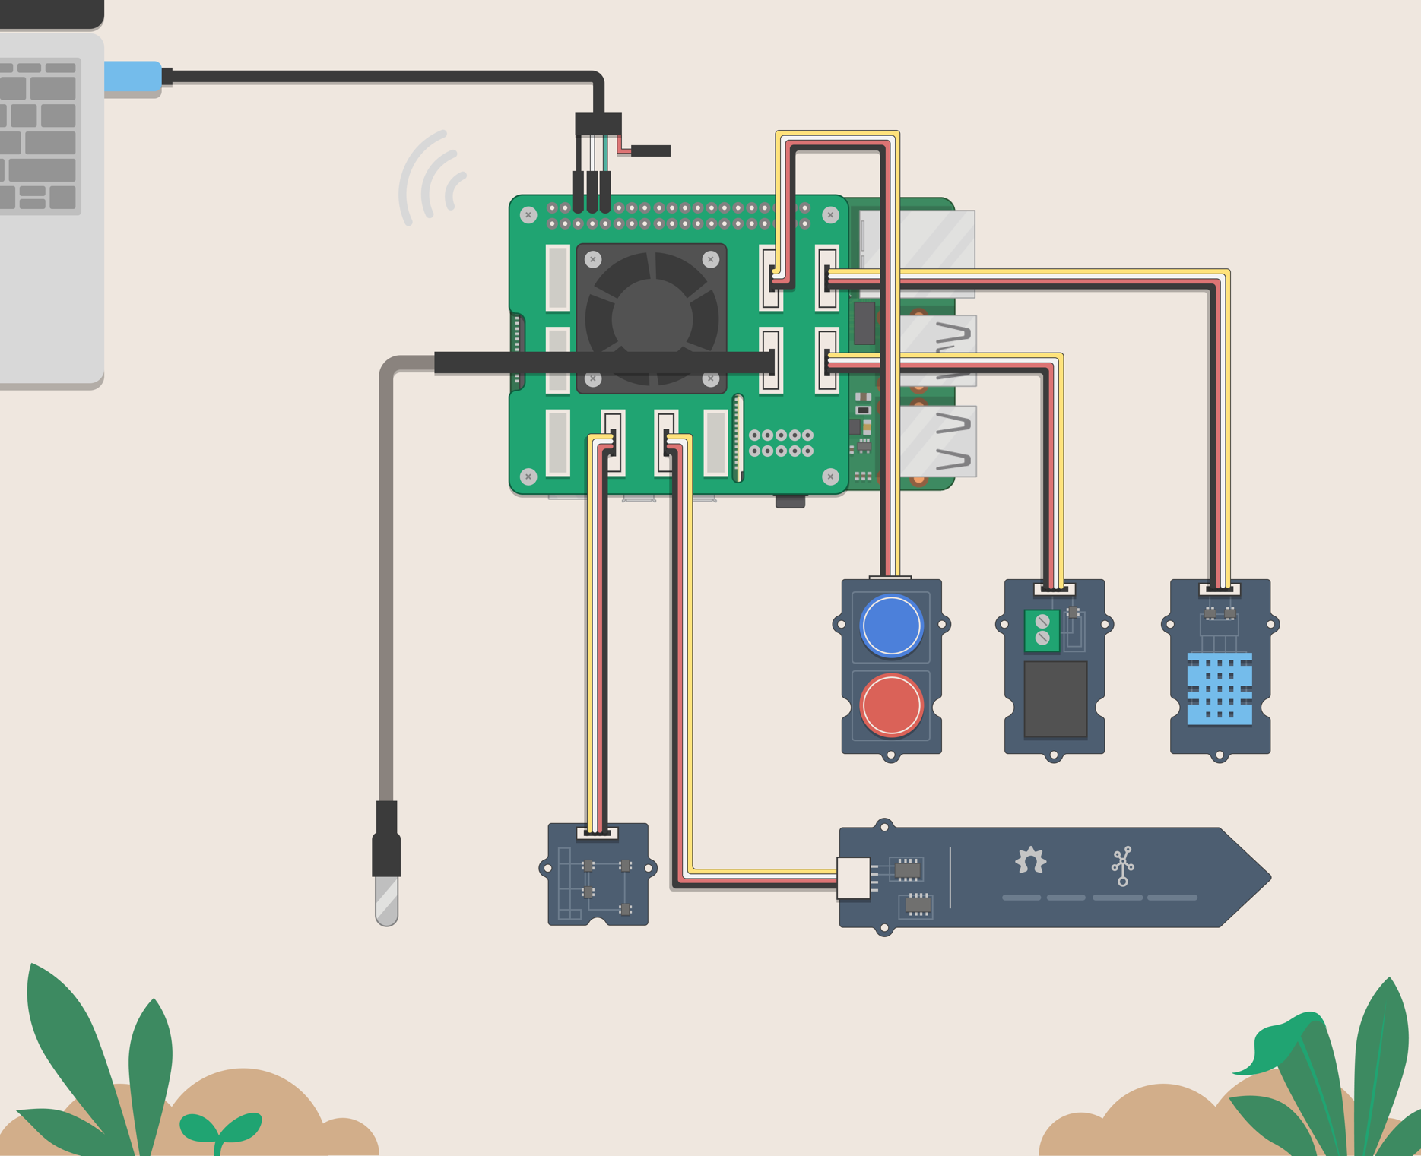

**FARMBEATS FOR STUDENTS KIT**

Raspberry Pi Sensor Assembly

Lesson plan and more resources are available at: [aka.ms/farmbeatsforstudents](../Curriculum%20-%20Draft%20Documents%20In%20Progress/aka.ms/farmbeatsforstudents)



Activity Overview

Farming is increasingly more technical, and students need to prepare for a data-driven approach to sustainable agriculture. Students build a garden monitoring system using environmental and soil sensors to understand the health of their soil and to predict the best time to water their plants.

Please note that lesson activities require adult supervision.

Build and learn

Students build their garden monitoring system using a Raspberry Pi 4 Small Board Computer (SBC), a Grove Base Hat for Raspberry Pi, and a selection of environmental sensors.

## Connect your tools

Students connect their garden monitoring system to the Excel workbook via the Raspberry Pi. Students use the Excel workbook to visualize and observe how the sensors operate.

## Visualize the data

Students use the garden sensors to visualize and compare the variety of data that is captured from the Raspberry Pi. The sensor data is collected by the Raspberry Pi and sent via Data Streamer to Excel for real time visualization.

## Lesson plan

The lessons enable students to be scientists, conducting tests that examine soil health and environmental conditions to make comparisons across tested soil metrics and large data sets.

Contents

**02** Activity Overview

**03** How It Works

**04** Kit Contents

**05** Building the Kit

**20** Visualizing Data with Excel

**24** Appendix

Hack our Projects

We love innovation and encourage you to hack our projects and make them your own. Submit your ideas at [aka.ms/hackingstem](https://aka.ms/hackingstem)

*FFA content is used with FFA's approval, and in accordance with the applicable FFA guidelines, solely for use in Microsoft educational materials. Any downloading, copying and/or reuse of such content is governed by FFA Media Usage Guidelines, FFA Advertising Guidelines, Merchandising Guidelines, and by applicable law.*

The FarmBeats for Students Kit is a garden monitoring system that consists of the Raspberry Pi 4 SBC, several environmental sensors that monitor soil and atmospheric conditions, and a relay indicator/actuator.

The kit performs four functions:

* Collects the sensor data
* Transmits the data to Excel
* Manages the data logger file
* Manages the reactive agent

This garden monitoring system allows students to study their garden environment and to make decisions based on the data they collect.

How It works

## **Raspberry Pi 4**

At the heart of the kit is the Raspberry Pi 4 SBC. The Raspberry Pi is responsible for collecting the sensor data, transmitting the data to Excel, managing the data logger file, and managing the reactive agent.

## **Data Logger**

To facilitate longer term data acquisition there is a data logger that can store data in a log file on the Raspberry Pi. The log file is used to collect data over time for later retrieval and analysis. The data logger is controlled by using Data Streamer and Excel using a custom workbook.

## **Sensors**

The kit includes a set of several environmental sensors that monitor soil and atmospheric conditions. The sensor data is collected by the Raspberry Pi and transmitted through the serial port to Microsoft Data Streamer Add-In for Excel for real time visualization.

## **Agent**

Students configure the reactive agent as an indicator that informs them when certain soil and environmental conditions are met. The agent can also be configured as an actuator that controls an external device such as a water pump, fan, or light. In this way the agent can automate data analysis and perform tasks based on current sensor data.

Kit Contents

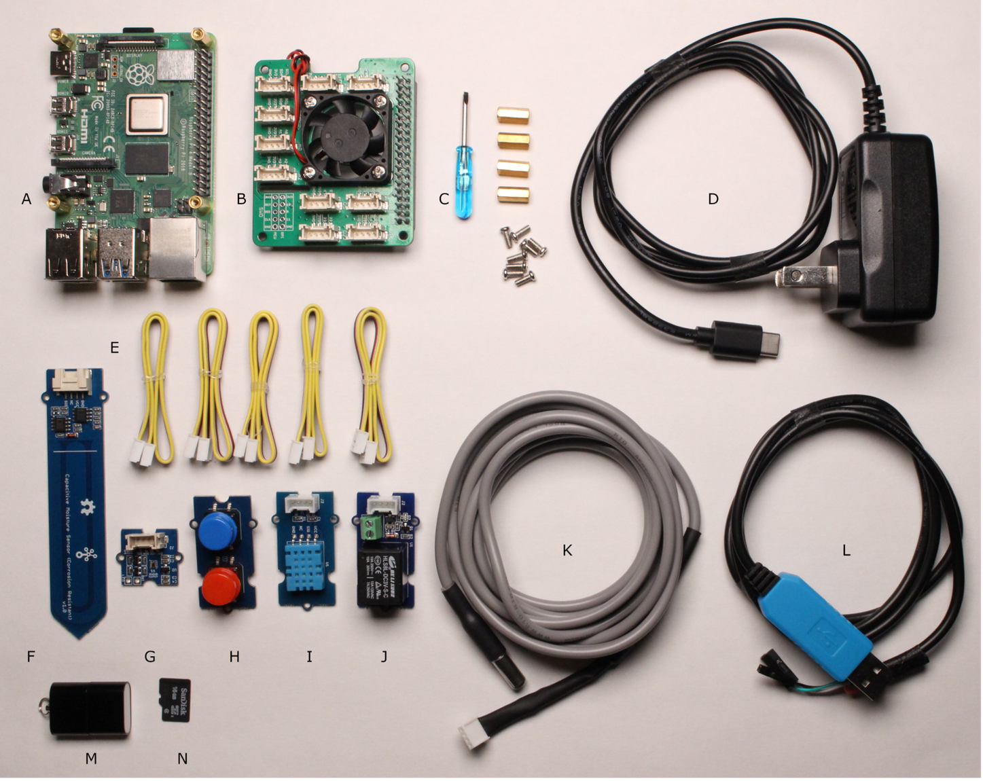

## **SD Card**

SD Card USB Adapter

SD Card 32GB

**M**

**N**

## **Sensors**

Grove Connectors

Grove Capacitive Soil

Moisture Sensor

Grove Sunlight Sensor

Grove Dual Button

Grove Temperature and

Humidity Sensor

Grove Relay

Grove OneWire Temperature Sensor

USB Serial Cable

**E**

**F**

**G**

**H**

**I**

**J**

**K**

**L**

Raspberry Pi 4

Grove Base Hat for Raspberry Pi

Screwdriver, screws, and standoffs for Base Hat

USB-C power supply

**A**

**B**

**C**

**D**

## **Raspberry Pi and Grove Pi Hat**

Building the Kit

This section will walk through the steps to building your kit starting with **unpacking your kit, assembling the sensors, powering up the Raspberry Pi, and connecting to Microsoft Excel**.

**Video**: Hardware Assembly, a “How To” Guide (<https://youtu.be/gUoFeWphX30>)

**Grove Pi Hat**

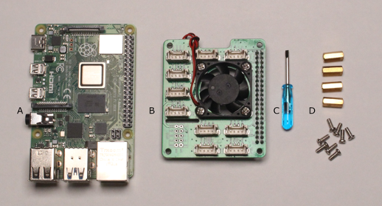

## **Safety Guidelines**

Adult Supervision Required

Eye protection

*Please wear appropriate eye protection while doing any engineering design or field projects.*

Warning

*Do not connect your Raspberry Pi to a power supply until instructed.*

## **Tools**

Philips screwdriver

**C**

Raspberry Pi 4

Grove Base Hat for Raspberry Pi 4

Screws and standoffs

**A**

**B**

**D**

## **Materials**

**Attaching the Grove Pi Hat**

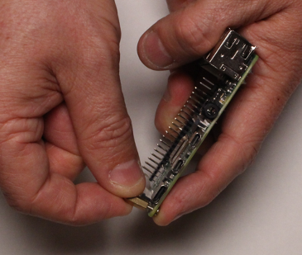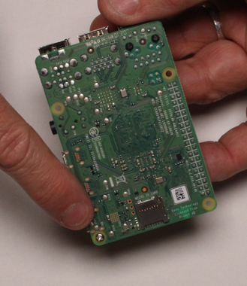

**1 |**

Insert one of the screws into one of the corner holes from the back of the Raspberry Pi.

**2 |**

While holding the screw with one finger, twist one of the standoffs onto the screw snugly.

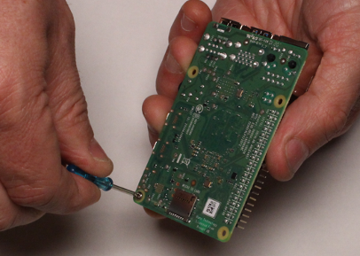

**3 |**

Tighten the screw into the standoff with your screwdriver. Repeat for the other 3 screws and standoffs.

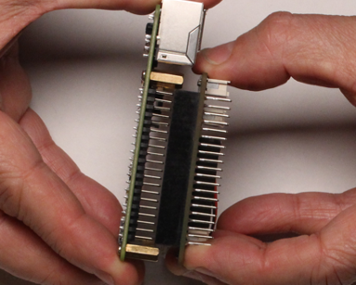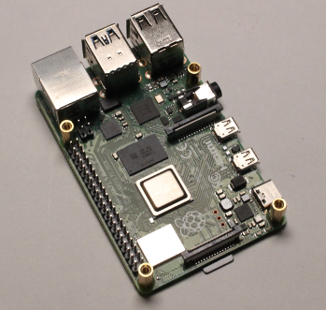

**5 |**

Carefully align the pins on the Raspberry Pi with the socket on the Grove Base Hat as shown and press firmly together.

**4 |**

Your Raspberry Pi should now look like the above photo and is ready to attach the Grove Base Hat.

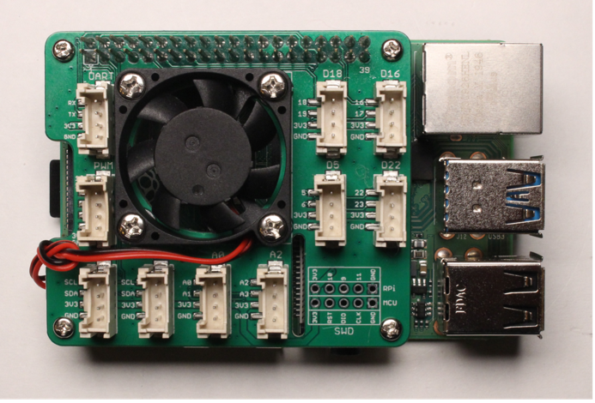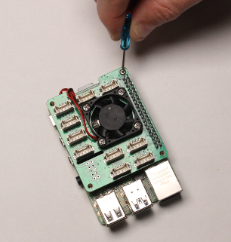

Congratulations!

Your Grove Base Hat is now firmly attached to the Raspberry Pi and ready to start attaching sensors.

**6 |**

Take one of the screws and insert it through the top of the Raspberry Pi and into the standoff. Use the screwdriver to tighten. Repeat for the other 3 screws.

CONNECTING THE SENSORS

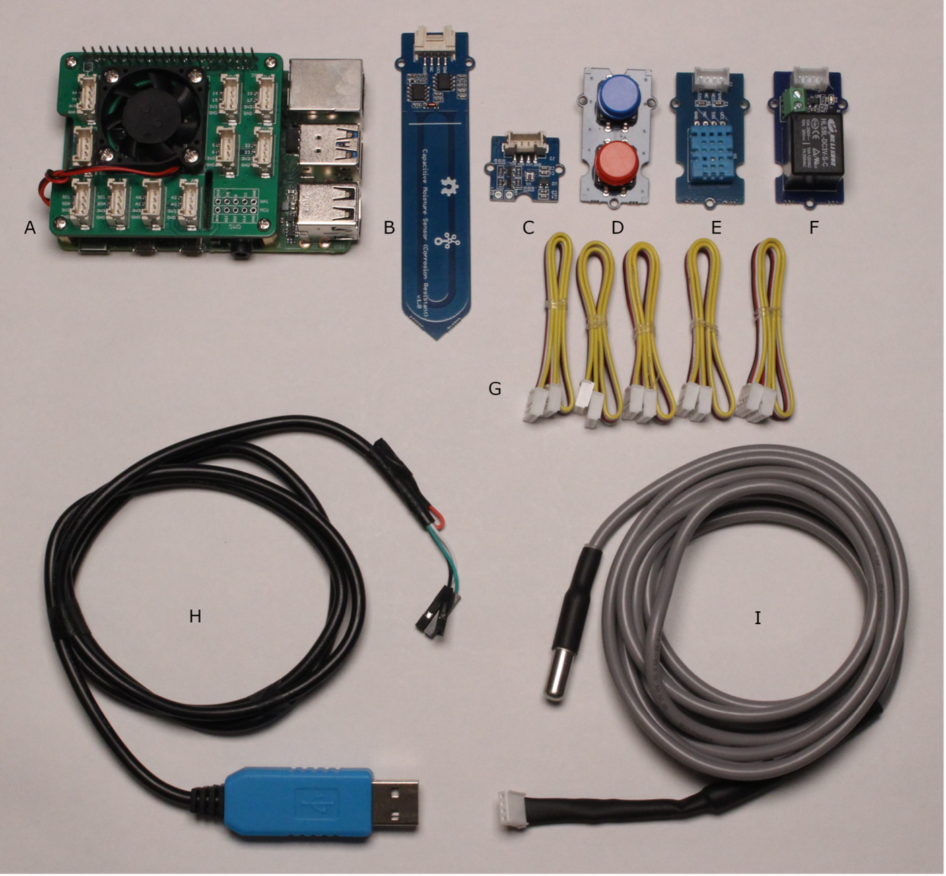

Raspberry Pi 4 and Grove Base Hat for Raspberry Pi

Grove Capacitive Soil Moisture Sensor

Grove Sunlight Sensor

Grove Dual Button Sensor

Grove Temperature and Humidity Sensor

Grove Relay

Grove Connectors

USB Serial-TTL Cable

Grove OneWire Soil Temperature Sensor

## **Materials**

**A**

**B**

**C**

**D**

**E**

**F**

**G**

**H**

**I**

### Environmental and soil sensors are used to capture data from your garden. The sensors included in the **FarmBeats** for Students Kit are connected to the **Raspberry Pi** using the **Grove Base Hat** which provides solderless connections. The computer code on the **Raspberry Pi** that reads your sensors will look for them at specific locations on the **Grove Base Hat** (except for the Sunlight sensor, which uses the I2C protocol and can use any of the I2C slots to connect the sensor). The sensors are plug-and-play and can be connected or removed while the Raspberry Pi is running.

Use the photo and reference table as a guide when connecting the sensors to the Grove Base Hat in the following sections. The numbered slots on your Grove Base Hat may not be in exactly the same location.:

**Grove Base Hat Connections**

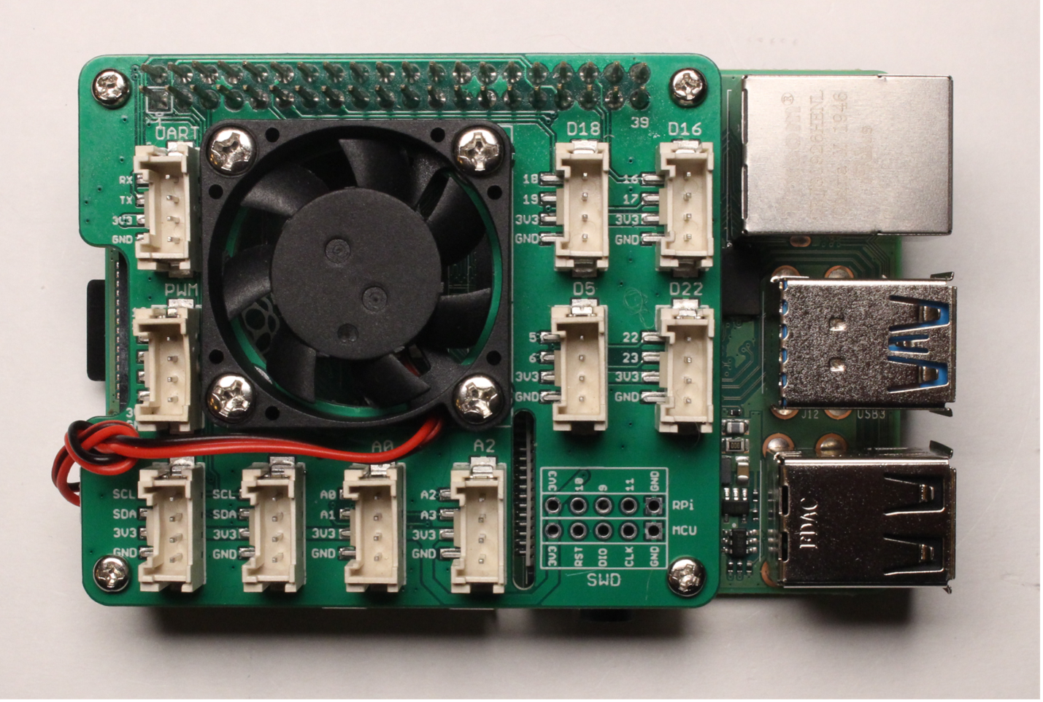

|  |  |
| --- | --- |
| **Sensor** | **Grove Base Hat slot** |
| Grove Soil Temperature Sensor | D5 |
| Grove Temperature and Humidity Sensor | D16 |
| Grove Dual Button | D18 |
| Grove Capacitive Soil Moisture Sensor | A0 |
| Grove Sunlight Sensor | Any slot labeled 12C |
| Grove Relay | D22 |

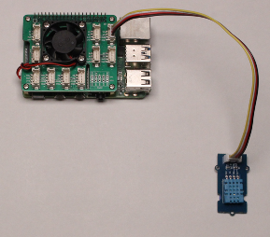

**Connecting the temperature and humidity sensor**

Connect the Grove Temperature and Humidity Sensor to slot D16.

The temperature and humidity sensors are based on the DHT11 digital sensor. This sensor will monitor the air temperature and relative humidity of your garden environment.

## **Temperature and Humidity Sensor**

## **Humidity Sensor**

The humidity sensor works by detecting changes in capacitance as humidity changes. The range of humidity is from 20% to 80% with an accuracy of +/-2% Relative Humidity.

## **Temperature Sensor**

The temperature sensor works by detecting changes in electrical resistance as temperature changes. The range of temperature of from 0 to 50 degrees Celsius (32 to 122 degrees Fahrenheit) with an accuracy of +/-2 degrees.

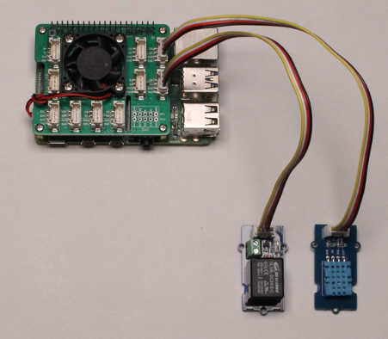

**Connecting the relay**

### Connect the Grove Relay Sensor to slot D22.

The relay switch is rated for much higher voltage and current. The rated load of the switch is 5 Amps at 250 volts alternating current (5A@250VAC) and 5 Amps at 30-volt direct current (5A@30VDC). This means that the relay can be used to switch on and off external devices with their own power supply such a water pumps, motors, lights, and fans.

There is a built-in LED light indicating the state of the relay, so the relay can be used as a visual indicator, and as an actuator when used as a switch to control another device.

A relay is a device that uses an electromagnet to control a switch that is connected to a circuit. This circuit is decoupled from the relay circuit allowing the relay to control a larger current. When the relay is activated, a 5-volt electrical current is applied to the electromagnet which pulls the contacts of the switch together making a circuit. When the current is removed a spring pulls the contacts apart breaking the circuit. The switch is normally open, meaning that the circuit is interrupted, or off by default. Activating the circuit turns the switch on.

The operating voltage of the Raspberry Pi is 3.3 volts, and the maximum current is 1.2 amps. The advantage of using a relay is that it can be used to control a circuit with a larger voltage and current.

## **Relay**

**Connecting the dual button sensor**

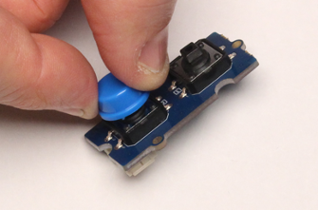

**1 |**

Attach the blue button cap so it is on the button closest to the Grove Connector. This will require some force to snap the button cap into place.

The dual button sensor is a pair of binary switches. There are 2 circuits that have a 5-volt current applied to one side and a voltage measurement on the other. The switch is connected to the circuit on one side and to the ground on the other side. When the buttons are not pressed the measured voltage is 5 volts. When the buttons are pressed the 5-volt current is shorted to ground and the measured voltage is 0 volts. These two button states produce the binary output of 0 or 1.

## **Dual button sensor**

## **Red power button**

The red button on your sensor is used to turn off the Raspberry Pi. To prevent accidental shutdowns the button must be pressed for longer than 6 seconds.

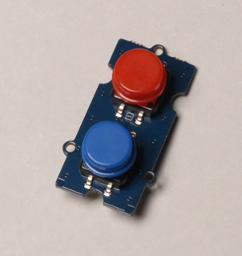

**2 |**

Attach the red button cap to the other button.

## **Blue data snapshot sensor**

The blue button is used to take a snapshot of the current sensor readings and write them to the log file on the Raspberry Pi when it is set to log data.

**3 |**

Take one of your short Grove Connector Wires and align it with the Grove Connector on the back of the sensor. The Grove connectors only fit one way. When it easily slips into the connector push it all the way in.

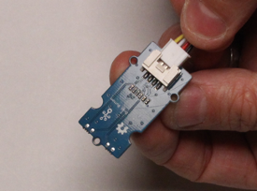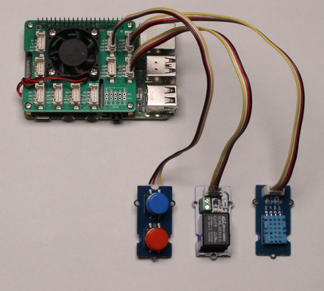

**4 |**

Connect the Grove Dual Button Sensor to slot D18.

**Connecting the soil temperature sensor**

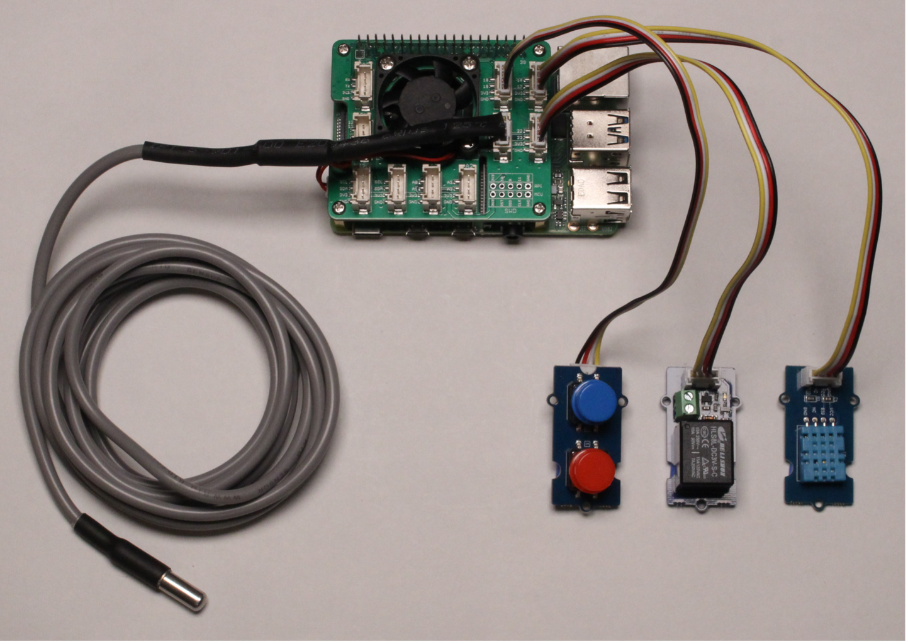

Connect the Grove OneWire Soil Temperature Sensor to slot D5.

## **Soil temperature sensor**

The soil temperature sensor is based on the DS18B20 semiconductor and is used to monitor the soil temperature in your garden. The sensor has a long wire with a waterproof capsule making it ideal for immersion in soil. The temperature sensor works by measuring changes in electrical resistance and converting that to a digital signal.

The range of temperature is -55 to +125 degrees Celsius (-67 to +257 degrees Fahrenheit) with an accuracy of +/-0.5 degrees.

**Connecting the capacitive soil moisture sensor**

## **Capacitive soil moisture sensor**

The capacitive sensor works by detecting changes in electrical capacitance in the soil as moisture levels change. The capacitance is converted to a voltage that is mapped to a range of numbers. This is a qualitative measurement in the soil and will produce a relative moisture level.

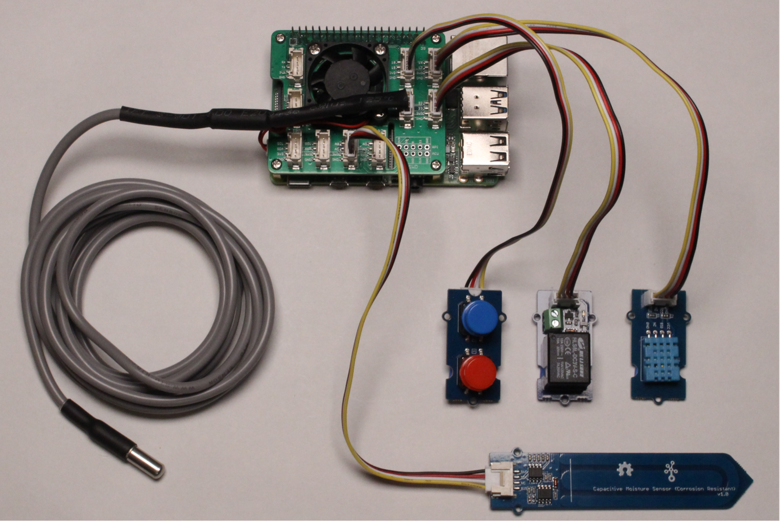

Connect the Grove Capacitive Soil Moisture Sensor to slot A0

**Connecting the sunlight sensor**

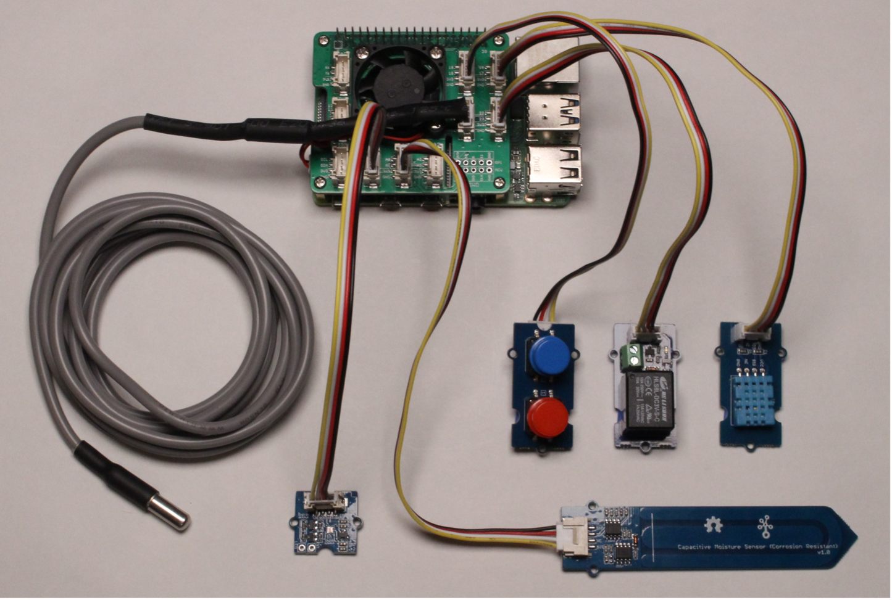

Connect the Grove Sunlight Sensor to any of the slots labeled I2C. This sensor will monitor visible spectrum light levels, ultraviolet light intensity, and infrared light levels.

The visible light sensor uses a photodiode that changes resistance when visible light levels change. The wavelengths of visible light detected is in the range of 400 to 700 nanometers.

## **Visible light sensor**

## **Ultraviolet sensor**

The ultraviolet sensor responds to specific regions of the electromagnetic spectrum in the range of 280 to 400 nanometers. These wavelengths are mapped to the Simplified UV Index System which produces a number from 0 to 11.

## **Infrared sensor**

The infrared sensor uses two photodiodes that work best in daylight and at night respectively. Infrared wavelengths are in the range of 700 to 950 nanometers.

The sunlight sensor is based on the SI1145 reflectance based ambient light, ultraviolet index, and infrared light sensor.

## **Sunlight sensor**

**Connecting the USB-TTL serial cable**

Connect the USB to TTL Serial Cable wires to the pins of the Raspberry Pi:

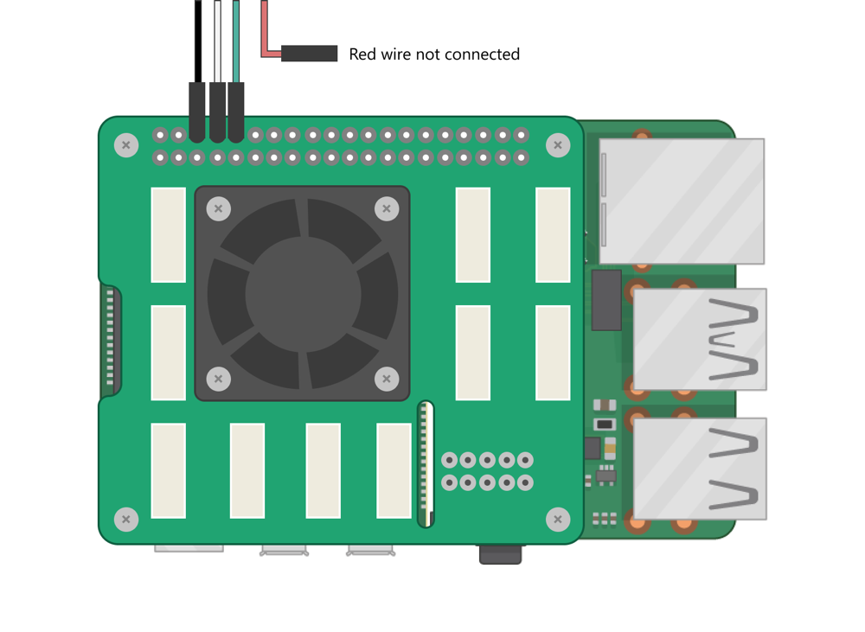

**Be very careful to leave a space of 2 pins at the end of the row.**

**Insert the Micro SD Card**

On the bottom of the Raspberry Pi, there is a micro–SD Card slot. Place your micro-SD card into this slot so that the printed side is visible. Push the card into the slot firmly. The SD card included in your kit will already be ready to use. If there are any issues with the SD card see Appendix: Flashing the SD Card.   
  
**Always remember to unplug the Raspberry Pi when inserting or removing the SD card.**

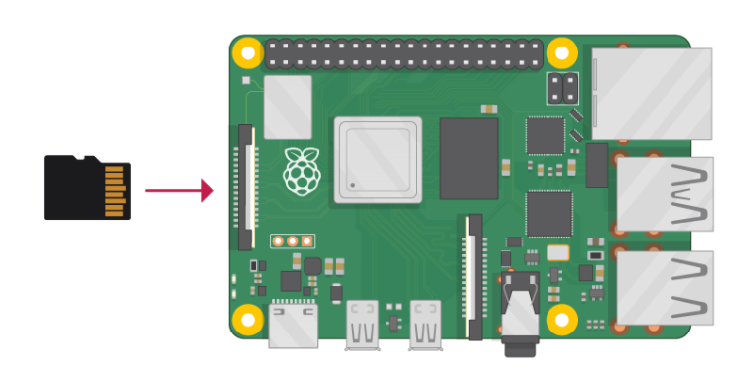

Your FarmBeats for Students Kit ships with an SD card that is ready to use. You will find the SD card inside the SD Card USB Adapter.

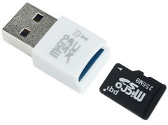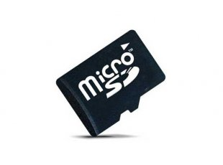

**Plug in USB cable into USB port**

Plug the serial data cable into a USB port on your computer.

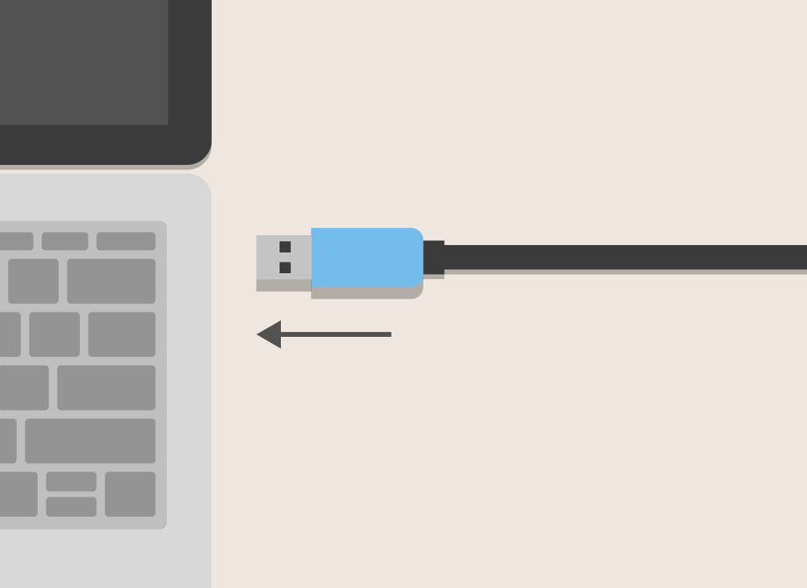

**Power up the Raspberry Pi**

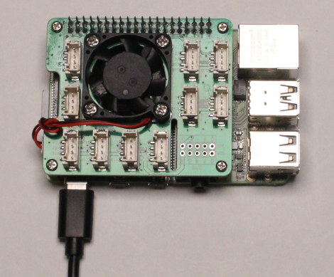

Plug the USB-C power supply into the Raspberry Pi and plug it into a power source. As soon as the Raspberry Pi is powered on it will begin to boot up and the red and green lights will flash on and off a few times. The first time the Pi boots up it will take 1 minute and 30 seconds while it is being configured. After that the boot time will take 30 seconds.

**1 |**

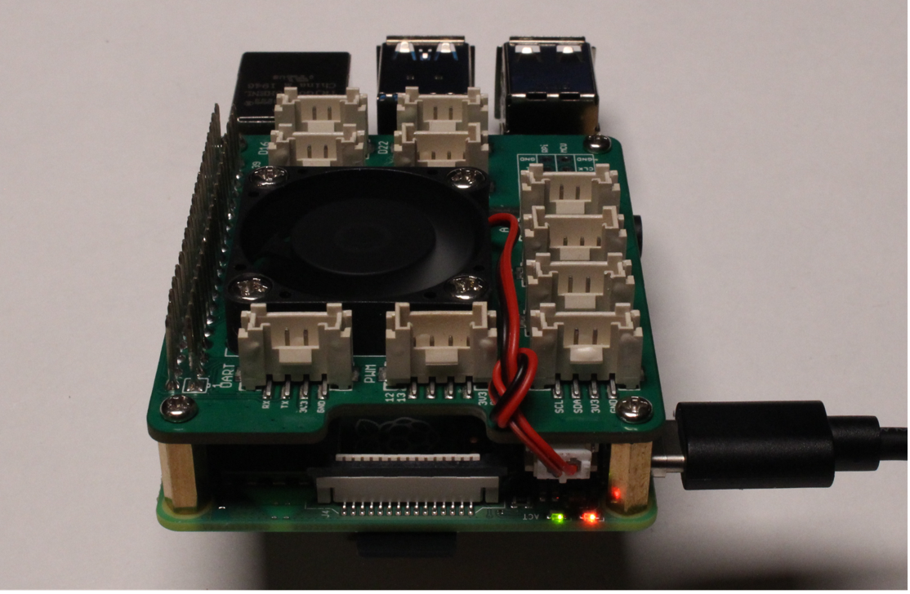

At the end of the boot cycle the Raspberry Pi is ready to use with Excel Data Streamer.

**2 |**

Congratulations! You are now ready to start exploring the sensor data of your garden monitoring system!

Visualizing Data with Excel

The data from your garden monitoring system can be visualized in Microsoft Excel.

**Enable Microsoft Data Streamer Add-in for Excel**

The O365 subscription includes Excel and the Data Streamer add-in free of charge.

**Select File** and choose **Options** located at the bottom of the pane.

**2 |**

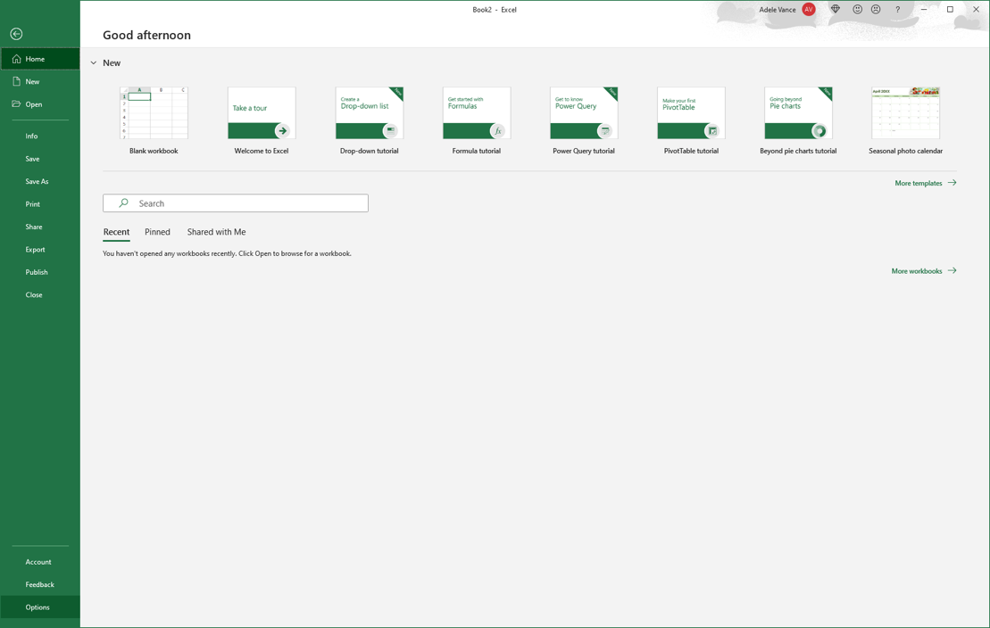

Open Excel 0365.

**1 |**

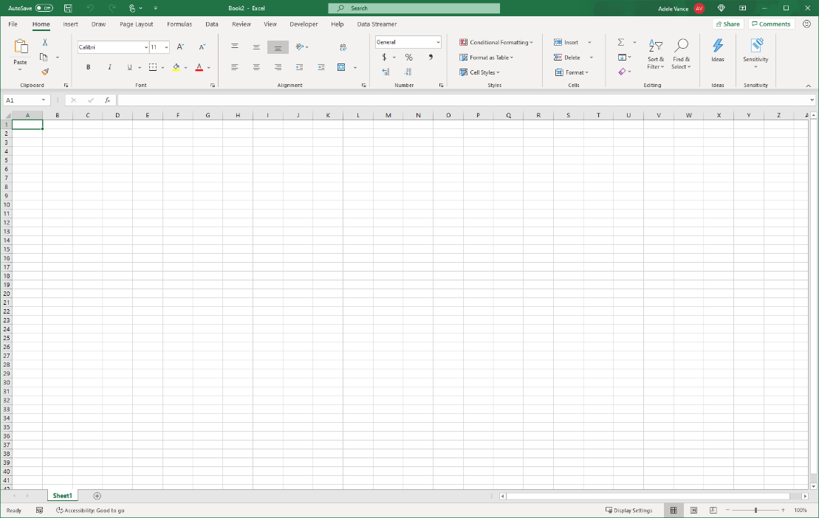

From the **Manage** menu at the bottom of the dialog box, choose **COM Add-Ins** and select **Go…**

**4 |**

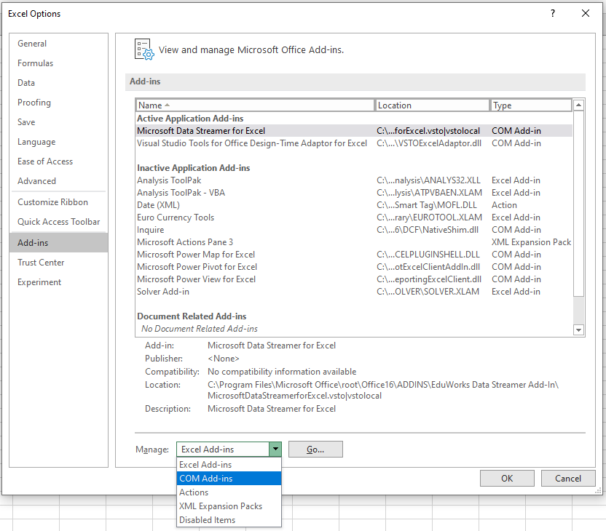

Choose **Add-ins** in the Excel Options dialog box.

**3 |**

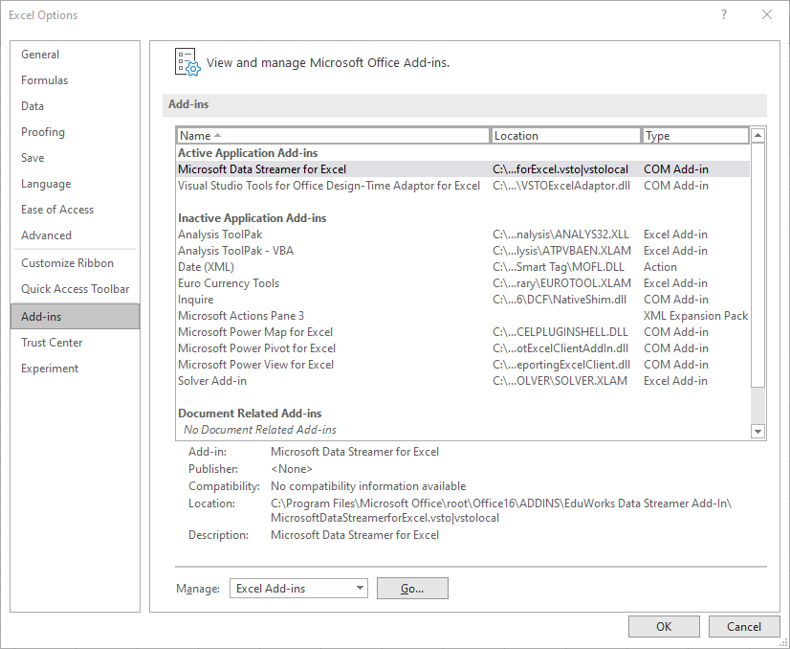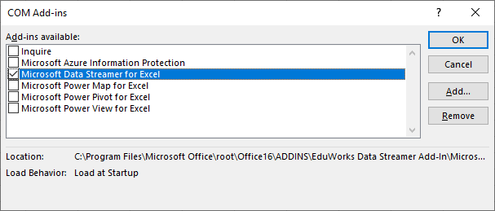

Check the box for **Microsoft Data Streamer for Excel** in the COM Add-ins dialog box and select **OK**.

**5 |**

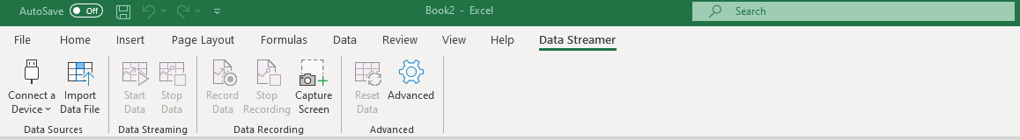

You should see a new Data Streamer tab in Excel’s menu ribbon.

**6 |**

**Getting data into Excel**

**Open the Excel FarmBeats Workbook**

If you haven’t already, download the Excel Workbook at <https://aka.ms/farmbeatsforstudents>   
To see live data, follow these steps:

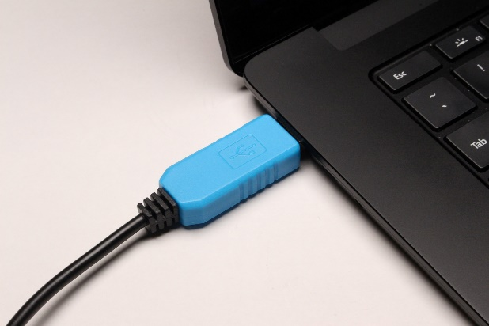

Plug the USB-TTL serial cable from your Raspberry Pi’s into your computer’s USB port.

**2 |**

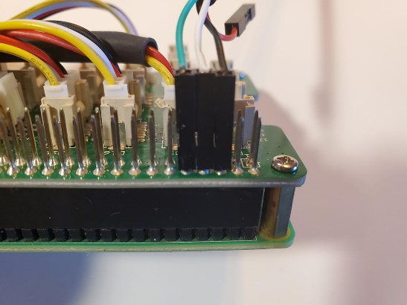

Plug the USB-C power supply into the Raspberry Pi and plug it into a power source.

**1 |**

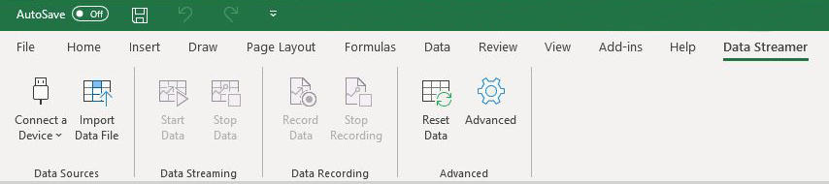

To connect your device, plug it into your computer via USB and then click “Connect a Device.”

Once your device is connected, select “Start Data” to begin streaming data into Excel.

In Excel, Data Streamer tab, select Connect a Device to connect the microcontroller to Excel.

**3 |**

In Excel, Data Streamer tab, select Start Data to begin reading data into Excel

**4 |**

**SD card image writing process**

Power off your Raspberry Pi and remove the SD card.

**1 |**

Insert the SD card as shown in the image above into the SD Card Adapter for USB.

**2 |**

Download the latest FarmBeats for Students SD card image: <https://aka.ms/FarmBeatsStudentsImage>  
The does not need to be unzipped. The file is large and may take a while depending on your internet connection and the speed of your computer.

Remember where this file is saved.

**3 |**

Appendix

**Flashing the SD Card**

**How to flash an SD card**

Your FarmBeats for Students Kit ships with an SD card that is ready to use. If there have been software upgrades, or if you have technical problems, you may be instructed to flash your SD card. If instructed, follow these steps to flash the SD card with the FarmBeats for Students Kit SD Card Image.

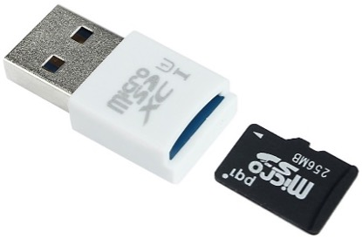

**Laptop or Desktop with SD card adapter for USB**



**SD card**

*Image Source: https://www.olimex.com/*

Go to the Raspberry Pi Foundation website, navigate to the downloads page, and download the Raspberry Pi Imager program appropriate for your Operating System: [www.raspberrypi.org/downloads](http://www.raspberrypi.org/downloads).

**4 |**

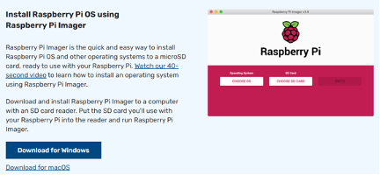

When the download is complete, open the file. If you are using the Chrome browser, you will see a notification in the Downloads Bar at the bottom left of your screen. Otherwise, navigate to the Downloads folder and double click the imager.exe file.

**5 |**



When prompted with “Do you want to allow this program to make changes to your device?”, click “Yes”. This requires admin privileges since it is a low-level disk utility. If you do not have admin privileges, contact your IT department for help.

**6 |**

Work through the Setup Guide to install the Raspberry Pi Imager program.

**7 |**

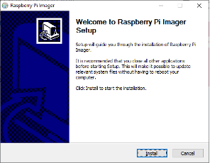

Once installed run the Raspberry Pi Imager program.

**8 |**

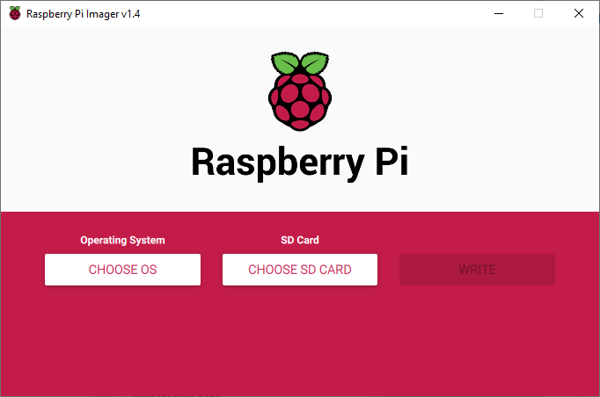

Click CHOOSE OS to open the Operating System menu. Scroll down and select Use Custom.

**9 |**

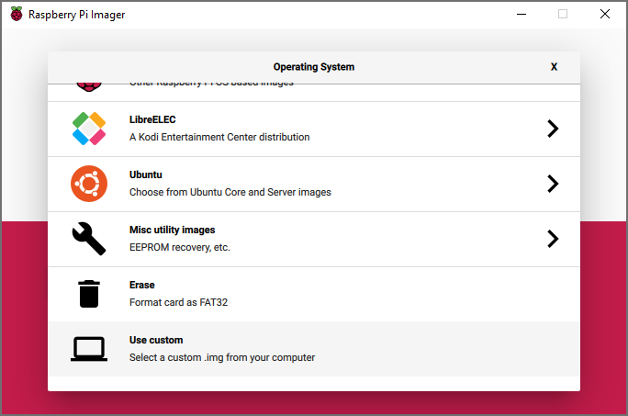

Navigate to the FarmBeats SD card image downloaded in step 3. The image is a .zip file. It is not necessary to unzip the file.

**10 |**

If you haven’t already, insert the SD Card Adapter for USB with the SD card into your computer.

**11 |**

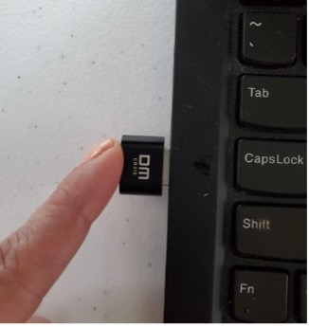

In the Raspberry Pi Imager program click CHOOSE SD CARD and select the SD card you inserted in step 11.

**12 |**

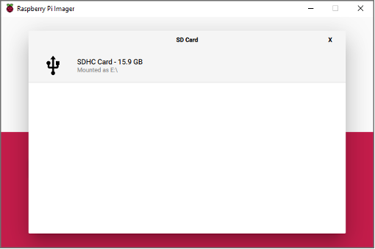

Click Write!  
**It can take up to 60 minutes depending on the specifications of your computer.**

**13 |**

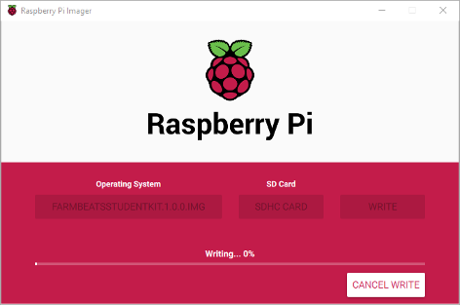

Once the process is complete, a notification window will open letting you know that it is OK to remove the SD card. Unplug the SD Card Adapter from your computer, remove the SD card from the adapter, and reinsert the SD card into the Raspberry Pi. **Always remember to power off the Raspberry Pi before inserting or removing the SD card**.

**14 |**



To power up the Raspberry Pi, plug the USB-C power supply into the Raspberry Pi and plug it into a power source.

**15 |**